**Overview**

The CAA Box Upload Widget is a feature that temporarily allows someone to upload file(s) to your Box account, even if the other person does not have their own Box account. Through this Widget, you simply send them a request, called a Shared Link, which lets them upload files directly to your Box account. This feature removes the need for others to send attachment emails, and places the files right into your Box, making it available across all your platforms and devices.

**Set-Up and Configuration**

Contact the CAA Service Desk **(insert email / phone here**) for help with the software set up. There is no other configuration needed.

To request a file from someone without a Box account, follow these steps:

1. Navigate to your Shared folder, and locate the CAA Upload folder.

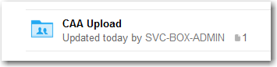

1. Inside the CAA Upload Folder, you will find the CAA Upload Widget

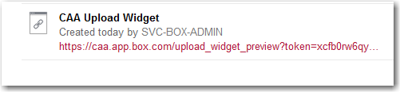

1. 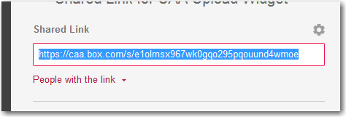Next, you'll need to copy the Shared Link of the Widget. Do this by clicking the **Shared** button, and then copy the Link.

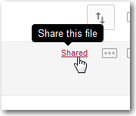

1. Once you copy this Shared Link, you can paste it into an email or chat option. Send this Shared Link to the person who has the file(s) you want to receive.
2. The other person will see the screen below. They can then choose the file to upload from their computer, and add a description if desired. Their email is required.

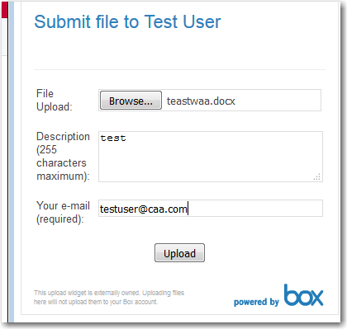

Keep in mind there is no status indicator for uploads in progress.  
Your colleague should wait to for the page update and see that the file was uploaded successfully.

1. You will now see the uploaded file in the same directory as the CAA Upload Widget. The file will contain the description and email given from the other person.

**FAQs**

* **Do I need to make a Box account?**

You will need a Box account, but your colleague will not. You'll also need a way of sending them the Shared Link, of course, such as email or chat.

* **What file types are compatible with the Box Upload Widget?**

Any file that you would normally upload via Box can be uploaded through the Widget.

* **The file didn’t seem to upload. What happened?**

The file should be in your CAA Upload Widget directory. However, because there is no status indicator for uploads in progress, the upload may not have finished on the other end. Make sure your colleague waits to see “Uploaded Successfully” before they finish.